Nepal College of Information Technology
Assessment
Spring 2012
Program : IT Time : 3 hrs
Semester : (I) FM : 100
Subject : Network Theory PM : 50

- Candidates are requested to give their answer as far as practicable in their own words.
- The figure in the margin indicates the full marks
- Attempt ALL question

 | - In the given circuit switch 'K' is closed at t = 0, finds 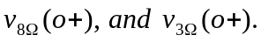  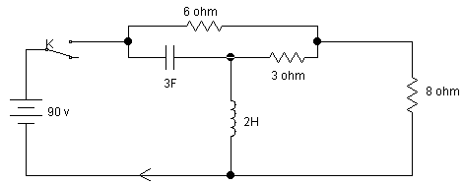  b) Determine the solution of the current differential equation, I" (t) + 3i' (t) + 2i (t) = 4e^{t}, initial conditions I (0+) = 1, i' (0+) = - 1. Use classical method | 7  8
 | - Derive an expression for current i(t) for second order network consisting of resistance R inductance L Henry and capacitance C Farad when a step voltage of V volts is applied at time t = 0. Determine the natural frequency and damping coefficient of the network. Also sketch i(t).  - A sinusoidal voltage 25 sin 10t is applied at time t = 0 to a series R-L circuit comprising R = 5Ω and L = 1H. By the method of Laplace transformation, find current i(t). Assume zero current through inductor before application of voltage. | 8  7
 | a) What are the advantages of laplace transform over classical method? For the network given below, obtain the voltage transfer function V2(s)/V(s).  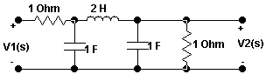  b) The denominator polynomial of a network is given as  S⁴+S³+S²+S+K=0  Determine the range of K for which the system is stable using  Routh- Hurwitz criteria. | 7  8
 | - Plot the poles and zeros in s-plane for the network function:  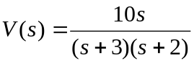  Also, obtain v(t) using pole-zero diagram.  - Find z and y parameters of the given circuit.  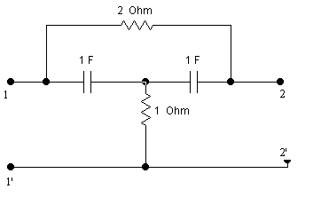 | 8  7
 | - In the circuit shown below the switch is moved from position 1 to 2 at t=0. Determine i, di/dt and d²i/dt² at t =0⁺.  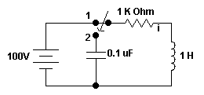  b)Check for the positive realness of given function [7] [One Port Network]  Z(s) = (2s²+2s+4)/(s³+2s²+s+2) | 8  7
 | a) Find ABCD parameters for the network given below by first finding Z  parameters and converting to ABCD.  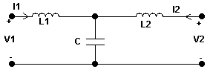  - Find the short circuit admittance parameters of the following two port network. All resistors are in ohm.  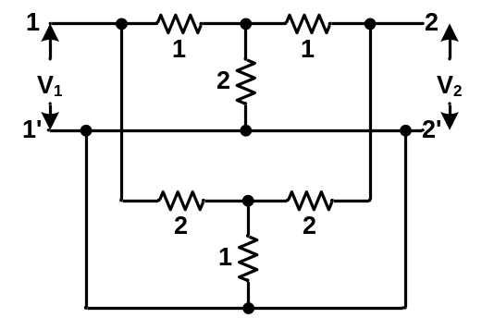 | 8  7
 | Write short notes on (Any Two):  - Transient and steady state response  - Reciprocity and symmetry of a two port network  - Ideal and practical filters | 2×5

